**ME 315**

**THEORY OF MACHINES - DESIGN OF ELEMENTS**

Fall 2023

**Design Project**

Group Submission

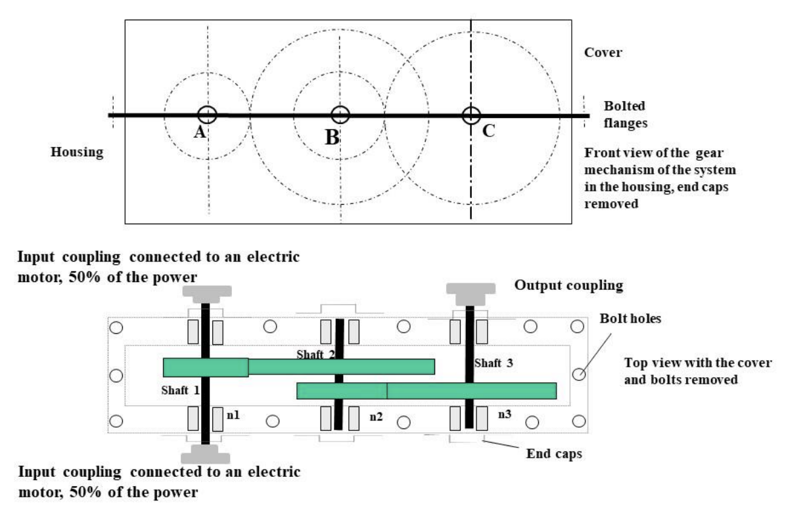

**Group members**

Chirag Bachani Shaft system 1

Winston Zhao Shaft system 2

Christopher Luey Shaft system 3

**Grade**

On-time step dues /5

Structural design, drawings /40

Design analysis /35

Report writing /20

Total __________

Final Project

Christopher Luey, Winston Zhao, Chirag Bachani

**Introduction 4**

**Gear Train 4**

**Gears 5**

**Shafts 6**

**Bearings 7**

**Assembly Drawings 8**

Shaft 1 8

Shaft 2 9

Shaft 3 10

**Shaft Drawings 11**

Shaft 1 11

Shaft 2 12

Shaft 3 13

**Gear Drawings 14**

Gear 1 14

Gear 2 15

Gear 3 16

Gear 4 17

**Shaft One Analysis 18**

Gearing 18

Force Analysis 20

Maximum Shear, Bending 21

Shaft Stress Analysis 21

Minimum Shaft Diameter 21

Infinite Life at Critical Cross Section 22

Yielding 23

Gear Stress Analysis 23

Bending 23

Contact 24

Factors of Safety for Bending and Contact 25

Bearing Selection 26

Expected Lifetime of Bearing 26

Keyways and Tolerances 27

**Shaft Two Analysis 30**

Gearing 30

Free Body Diagram 32

Force Analysis 34

Shear and Bending 34

Shaft Fatigue Analysis 34

Gear Stress Analysis 37

Material 37

Allowable Contact Stress 37

Allowable Bending Stress 39

Design Bending Stress 39

Bearing Selection 41

Expected Lifetime of Bearing 41

Keyways and Tolerances 43

**Shaft Three Analysis 44**

Gearing 44

Geometry 45

Force Analysis 46

Maximum Shear, Bending 47

Shaft Stress Analysis 48

Minimum Shaft Diameter 48

Infinite Life at Critical Cross Section 48

Yielding 49

Gear Stress Analysis 50

Bending 50

Contact 51

Factors of Safety for Bending and Contact 52

Bearing Selection 53

Expected Lifetime of Bearing 53

Keyways and Tolerances 54

# 

# Introduction

In our team's engineering project, we designed a robust two-stage gear transmission system depicted in the accompanying figure, aiming to efficiently transmit power from input shaft A to output shaft C with a speed reduction. The system, comprising input shaft A driven by two electric motors, center shaft B with corresponding gears, and output shaft C with a coupling set, was carefully arranged, considering the spatial relationship between A and C. Operating at 2600 rpm, the input motors delivered 70KW to shaft A, with the goal of achieving an output speed (n3) of around 400 ±3 rpm, assuming 100% overall efficiency. Our design incorporated fatigue stress concentration factors to address bending and torsional stresses, and determined geometry using a factor of safety of n=1.1. With a commitment to durability, the transmission system is expected to function continuously for at least 5 years, 7 days a week, 52 weeks a year, and 8 hours a day, with a reliability rate of 99%.

# Gear Train

| **Part** | **Gear 1** | **Gear 2** | **Gear 3** | **Gear 4** |
| --- | --- | --- | --- | --- |
| N [teeth] | 19 | 47 | 27 | 71 |
| RPM [rev/min] | 2600.000 | 1051.064 | 1051.064 | 399.700 |
| Power [kW] | 70.0 | 70.0 | 70.0 | 70.0 |

| **Gear Train Result** | |
| --- | --- |
| Ratio | 6.5049 |
| Output Speed (RPM) | 399.7003 |
| % Error | -0.0749% |

# 

# Gears

| **Gear Properties** | |
| --- | --- |
| Material | AISI 1045 Steel |
| Module [mm] | 5.00 |
| Pitch Angle [Deg] | 20.00 |
| Addendum [mm] | 5.00 |
| Dedendum [mm] | 6.25 |
| Clearance [mm] | 1.25 |
| Tooth Depth [mm] | 11.25 |

|  | **Gear 1** | **Gear 2** | **Gear 3** | **Gear 4** |
| --- | --- | --- | --- | --- |
| Material Grade | 2 | 1 | 2 | 1 |
| Hardness [HB] | 500 | 400 | 500 | 400 |
| Pitch Diameter [mm] | 95.0 | 235.0 | 135.0 | 355.0 |
| Outer Circle [mm] | 105.0 | 245.0 | 145.0 | 365.0 |
| Root Circle [mm] | 83.0 | 223.0 | 123.0 | 343.0 |
| Face Width [mm] | 65.0 | 60.0 | 65.0 | 60.0 |
| Centerline Distance [mm] | 165.0 | | 245.0 | |
| Bending Factor of Safety | 4.1069 | 3.0405 | 2.7465 | 2.0373 |
| Contact Stress Factor of Safety | 1.4576 | 1.1201 | 1.4859 | 1.1462 |

# 

# Shafts

|  | **Shaft 1** | **Shaft 2** | **Shaft 3** |
| --- | --- | --- | --- |
| Material | AISI 1045 Carbon Steel | | |
| RPM [rev/min] | 2600.0000 | 1051.0638 | 399.7003 |
| Max Bending Magnitude [Nm] | 205.7115 | 451.2470 | 343.7668 |
| Max Torque [Nm] | 257.096 | 635.975 | 1672.380 |
| Minimum Shaft Diameter [mm] | 17.000 | No pure torque | 40.000 |
| Critical Cross Section Location | Gear 1 Center | Gear 3 Center | Gear 4 Center |
| Shaft Diameter at Critical Cross Section [mm] | 45.000 | 60.000 | 55.000 |
| Goodman Factor of Safety | 1.8467 | 1.8236 | 1.6866 |
| Yielding Factor of Safety | 7.3976 | 7.3851 | 6.3999 |
| Lifetime | Infinite (> Cycles) | | |

# 

# Bearings

|  | **Shaft 1** | | **Shaft 2** | | **Shaft 3** | |
| --- | --- | --- | --- | --- | --- | --- |
| As shown in Assembly Drawing | Left | Right | Left | Right | Left | Right |
| Radial Load [N] | 1645.692 | 4114.230 | 8204.490 | 6835.208 | 6875.336 | 3151.196 |
| Thrust Load [N] | 0 | | 0 | | 0 | |
| Equivalent Load Used in Calculation [N] | 4114.230 | | 8204.490 | | 6875.336 | |
| C [N] | 54081.734 | | 79744.149 | | 48414.597 | |
| Bearing (SKF) | 6309 | | 6312 | | 6311 | |
| Bore [mm] | 45 | | 65 | | 55 | |
| OD [mm] | 100 | | 140 | | 120 | |
| Width [mm] | 25 | | 33 | | 29 | |
| C, bearing [N] | 55300 | | 97500 | | 74100 | |
| C0, bearing [N] | 31500 | | 60000 | | 45000 | |
| Expected Life [Mil Cycles] | 2428.3404 | | 1678.2594 | | 1251.9091 | |
| Expected Life [Yrs] | 5.3455 | | 9.1288 | | 17.9265 | |

# 

# Assembly Drawings

## Shaft 1

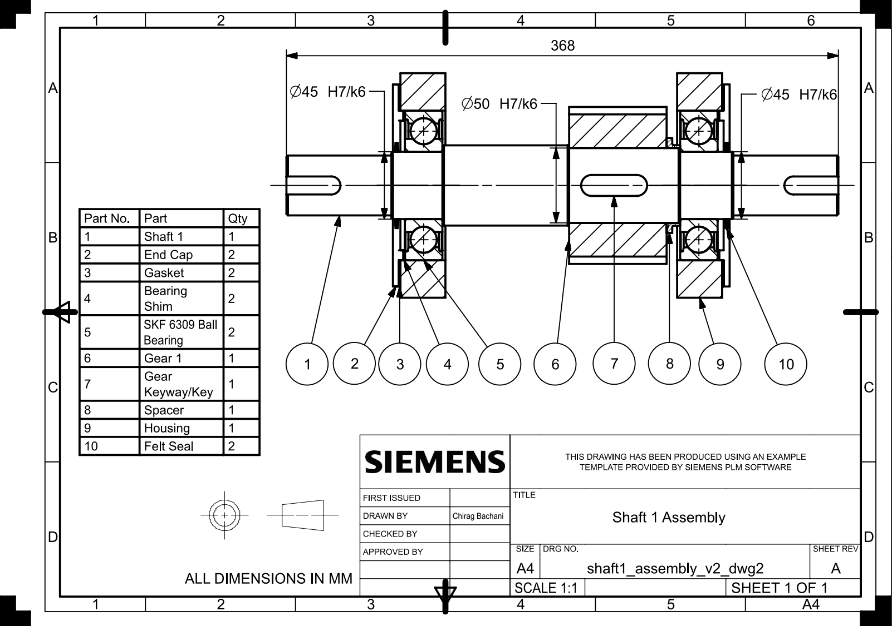

## 

## Shaft 2

## 

## 

## Shaft 3

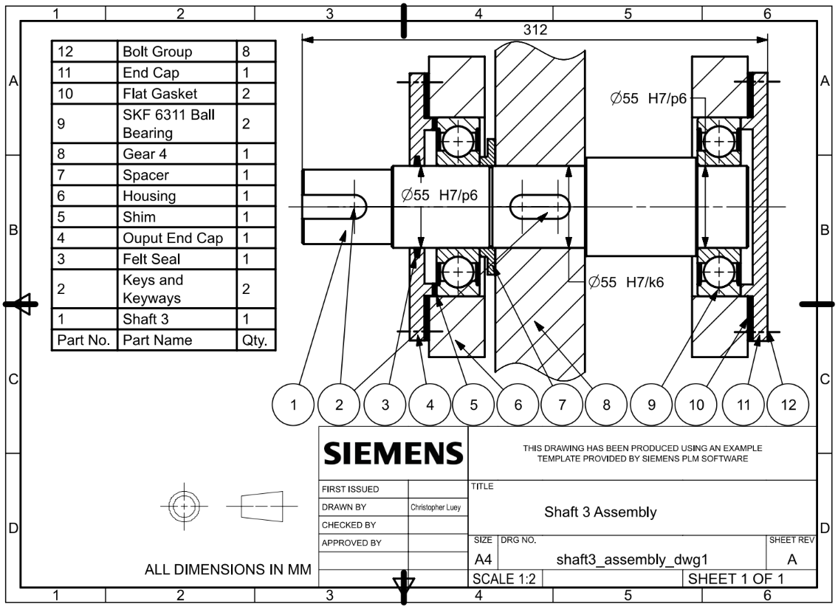

# 

# Shaft Drawings

## Shaft 1

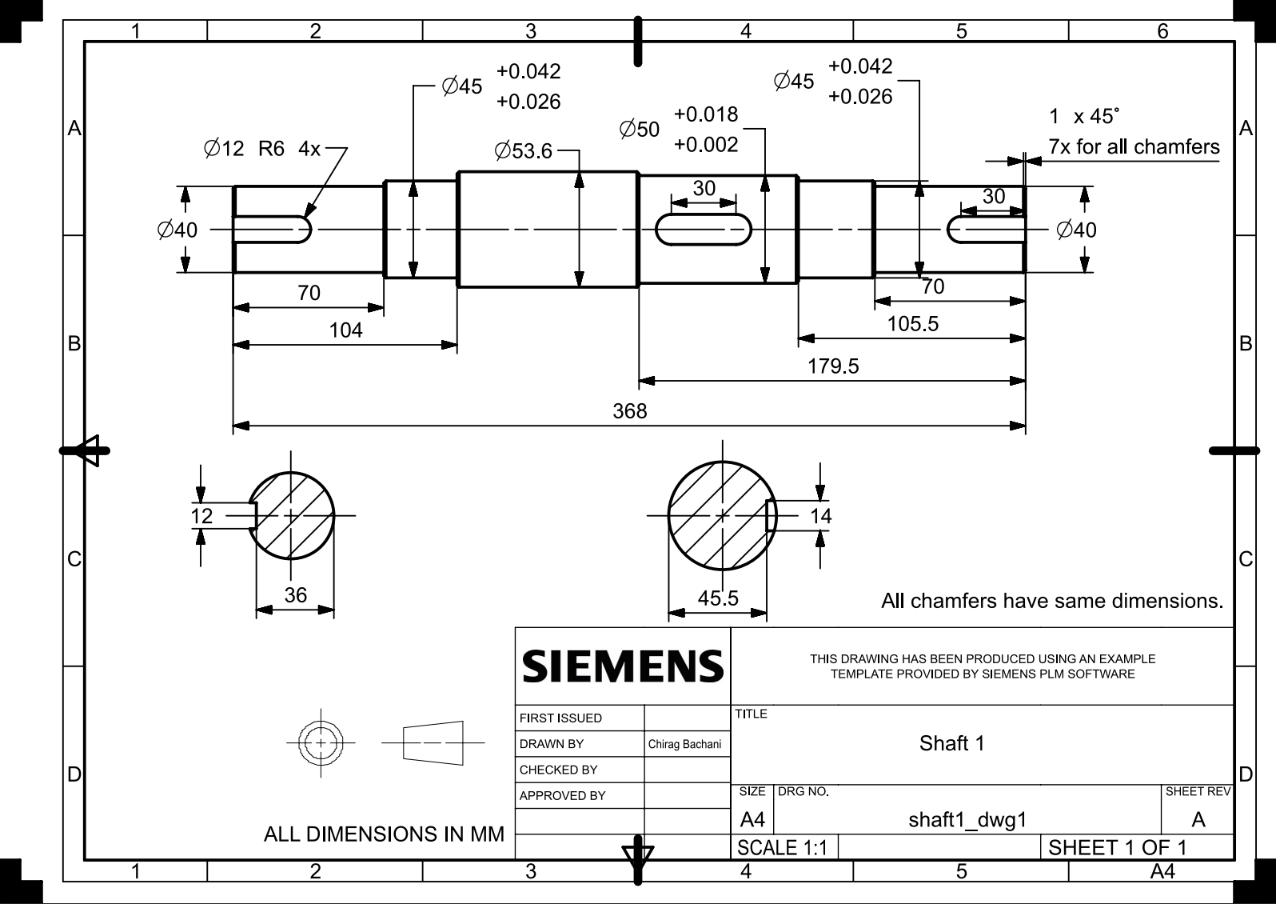

## Shaft 2

## 

## 

## Shaft 3

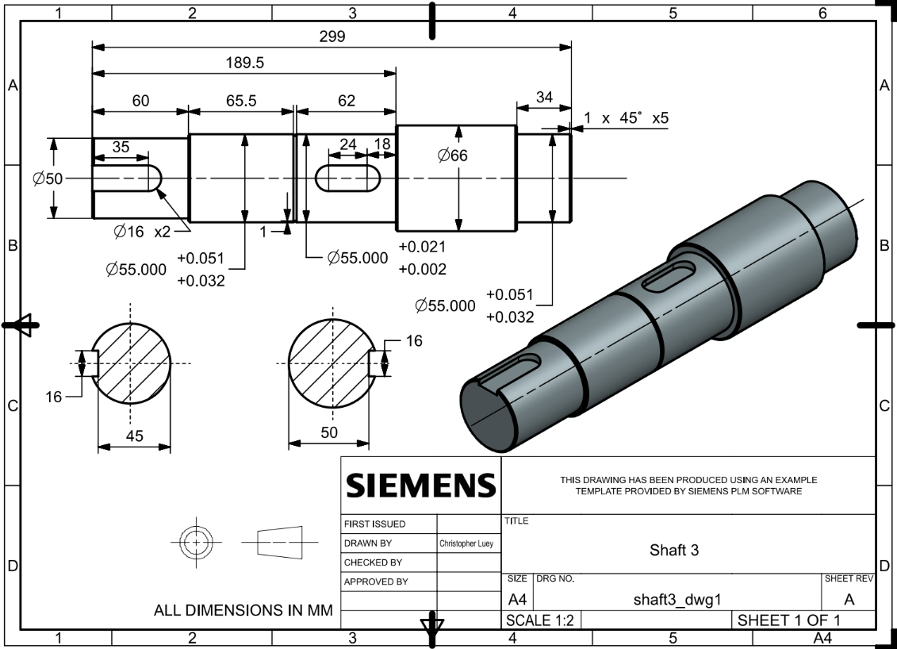

# 

# Gear Drawings

## Gear 1

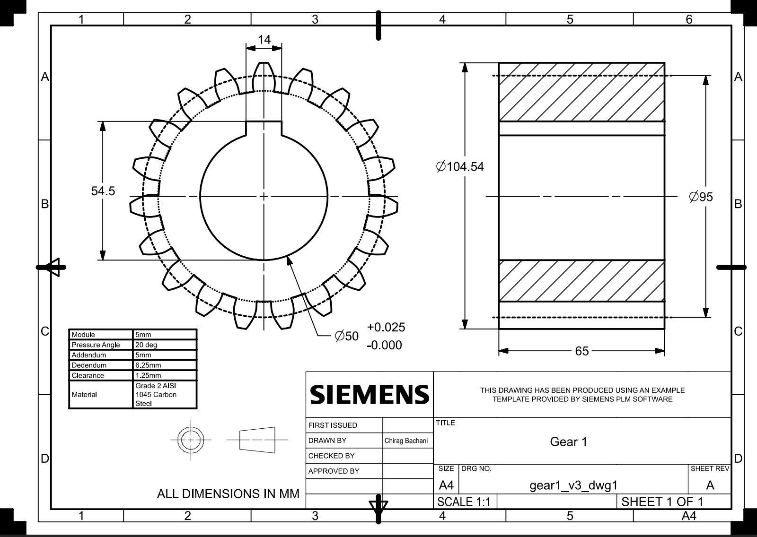

## 

## Gear 2

## 

## 

## Gear 3

## 

## 

## Gear 4

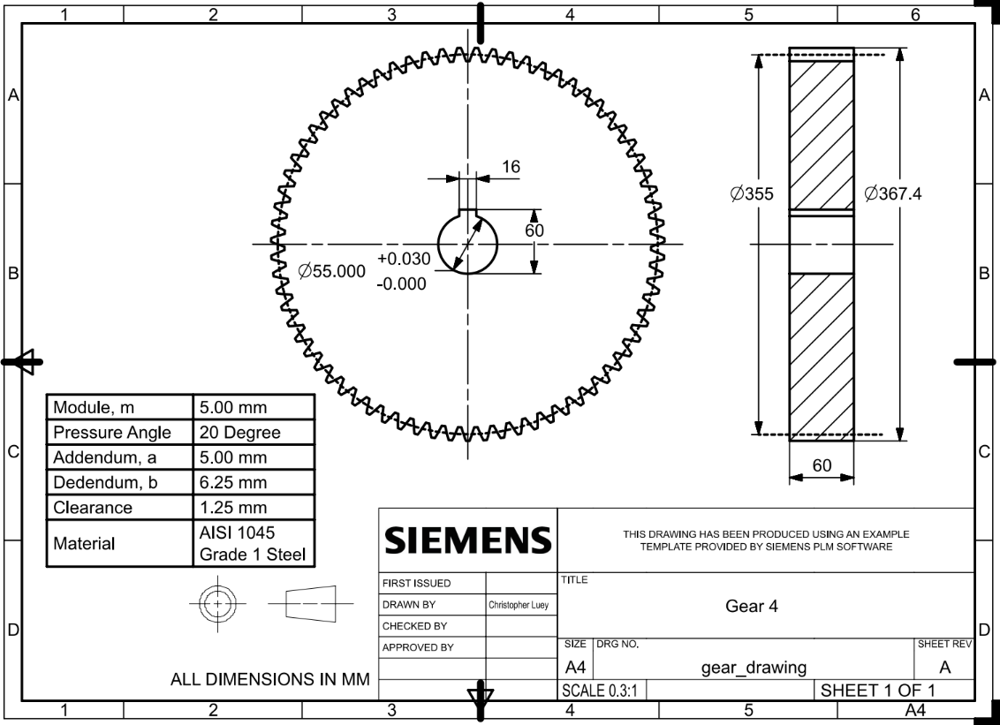

# 

# Shaft One Analysis

## Gearing

Given: n1 = 2600 rpm, H = 70000 W, n3 (ideal) = 400, n1/n3 (ideal) = 6.5

Choose gear teeth (odd number, indivisible):

N1 = 19

N2 = 47

N3 = 27

N4 = 71

Choose standard module and pitch angle for off the shelf ordering:

m = a = 0.005 [m]

b = 1.25m = 0.00625 [m]

= 20 degree

Calculate transmission ratio:

n1/n3 = N4*N2/(N1*N3) = 6.5049

n3 = 2600/(n1/n3) = 399.7003 rpm

% error = |(n3-400)/400| = -0.0749%

**Gear 1**:

Geometry

N1 = 19

Pitch Diameter:

Pitch Radius:

Face Width:

Forces

*Note: Forces acting from Gear 1 to Gear 2 are the same as from Gear 2 to Gear 1*

Torque:

Gear Forces:

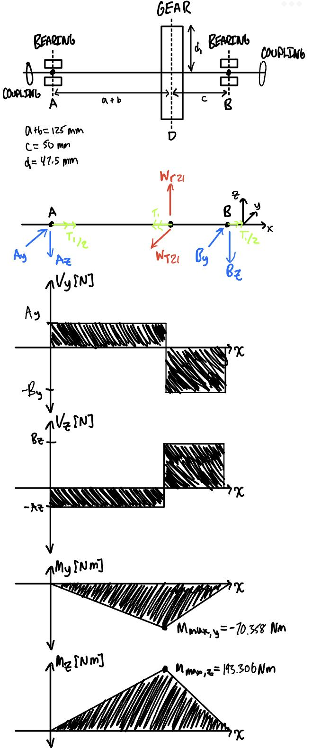



Note: Torque occurs in the same direction on both sides of the shaft, coming from the coupling.

## Force Analysis

From the gearing section the following are solved:

From geometry we know the following:

Derived from static equilibrium, solve this system of equations:

System of equations yields the following reactions with force directions as drawn:

Ay = 1546.4448 N

Az = 562.8599 N

By = 3866.1120 N

Bz = 1407.1497 N

## Maximum Shear, Bending

Maximum bending occurs at cross section C:

The shear magnitude at cross section C is:

Vy = Ay = 1546.4448 N

Vz = Az = 562.8599 N

## Shaft Stress Analysis

We first choose material:

| **Material** | **E (Pa)** | **UTS (MPa)** | **Poisson Ratio** | **Ys (MPa)** |
| --- | --- | --- | --- | --- |
| [AISI 1045 Steel](https://www.azom.com/article.aspx?ArticleID=6114) | 200000.0000 | 394.7200 | 0.2900 | 294.7400 |

### Minimum Shaft Diameter

Our factor of safety is n=1.1

Calculate the torque magnitude at the coupling:

Calculate the minimum shaft diameter:

Consider keyway effect, round 5% increase:

### Infinite Life at Critical Cross Section

Choose a shaft diameter of d = 45 mm at cross section C.

Solve for max bending torsion, and shear stresses at cross-section C experienced by point on the surface:

Given these stresses, calculate the mean and amplitude stresses for cyclic loading:

[The shaft turns on and off]

This is a conservative estimate, since we use the shear and bending stress maximum amplitudes in calculating stress states, although these maximums are out of phase. Furthermore, we do not ignore shear (which is 30% of the mean shear).

Calculate Von-Mises given Kf = 3.000 and Kfs = 2.800

Calculate Infinite Criteria given chosen material:

[Grinding]

[Size Factor]

[99% Reliability]

[Chosen shaft diameter at C is safe]

### Yielding

[Chosen shaft diameter does not pass yield line]

## Gear Stress Analysis

Choose material for gear:

| **Gear Materia** | **hardness** | **E (MPa)** | **Poisson Ratio** |
| --- | --- | --- | --- |
| AISI 1045 Carbon Steel | 400.0000 | 200000.0000 | 0.2850 |

### Bending

Calculate number of shaft cycles:

Rotation speed n1= 2600 RPM.

Calculate allowable bending stress:

Calculate actual bending stress:

[From Class Plot]

[module = 5 mm]

[Gear]

[Non Idler]

Calculate Kv:

for commercial gears

Comparing the allowable to the actual bending stress:

The design is sufficient for bending stress since nb > n = 1.1

### Contact

Calculate allowable contact stress:

since

MPa

Calculate actual contact stress:

[No shock]

[From bending calculation]

### Factors of Safety for Bending and Contact

MPa

[Safe for contact stress]

[Safe for bending stress]

## Bearing Selection

[life hours]

n3 = 2600 RPM [rotation speed]

[No Shock]

[Ball Bearing]

[A and B calculated in Force Analysis section]

[No Axial Force]

Given the calculated C, I specify the following bearing from SKF:

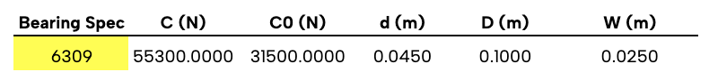

Reference: <https://www.skf.com/us/products/rolling-bearings/ball-bearings/deep-groove-ball-bearings/productid-6309>

This bearing is safe because the bearing specification C is less than our calculated C. Recalculation is not necessary since there is no thrust force and radial factor X is constant, not a function of e or C0.

### Expected Lifetime of Bearing

[using C=55300 N from SKF]

Bearing does not require maintenance for intended operation of 5 years.

## Keyways and Tolerances

Coupling Keyway (40 mm) and Gear Keyway (50 mm):

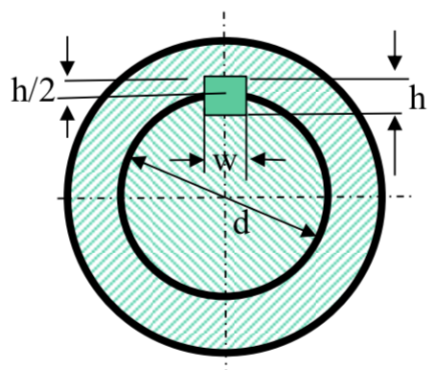

| Shaft diameter d (mm) | Key width W x height H |
| --- | --- |
| 38 < d <= 44 | 12 x 8 |
| 44 < d <= 50 | 14 x 9 |

Fits:

**Bearing and Shaft: Interference fit (H7/p6), bearing should be tightly fit with shaft for fluid rotation.**

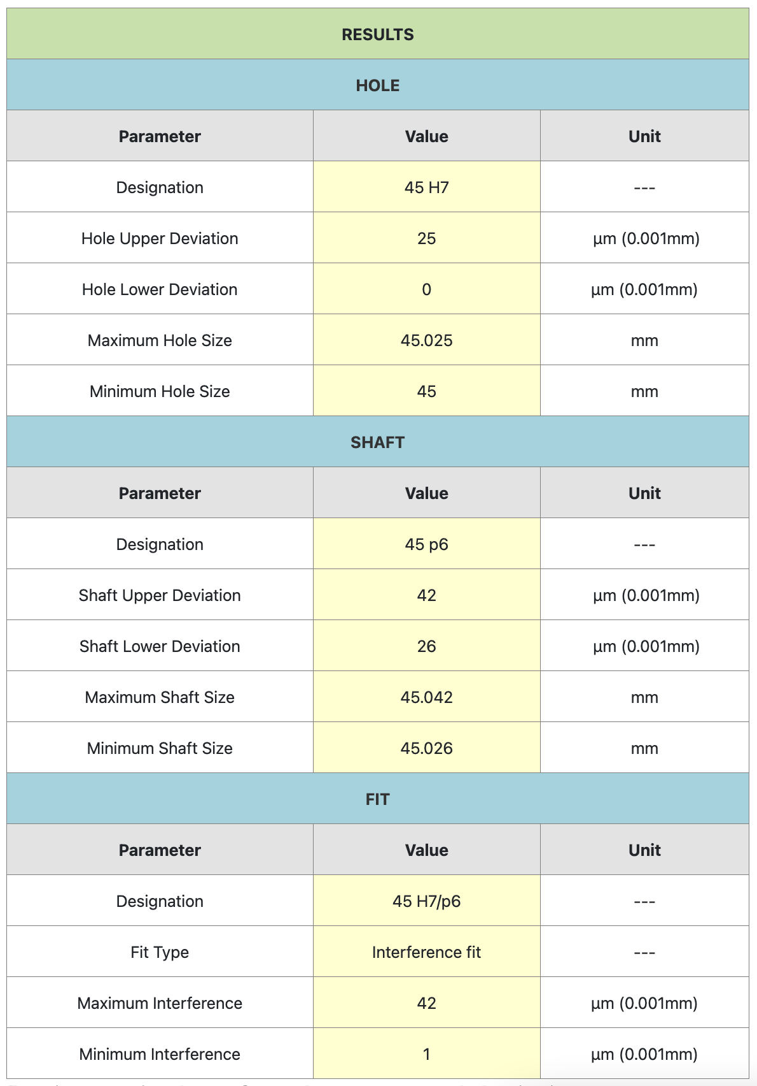

**Gear and Shaft: Transition fit (H7/k6), shaft rotation will be transmitted from gear torque through interlocked key.**

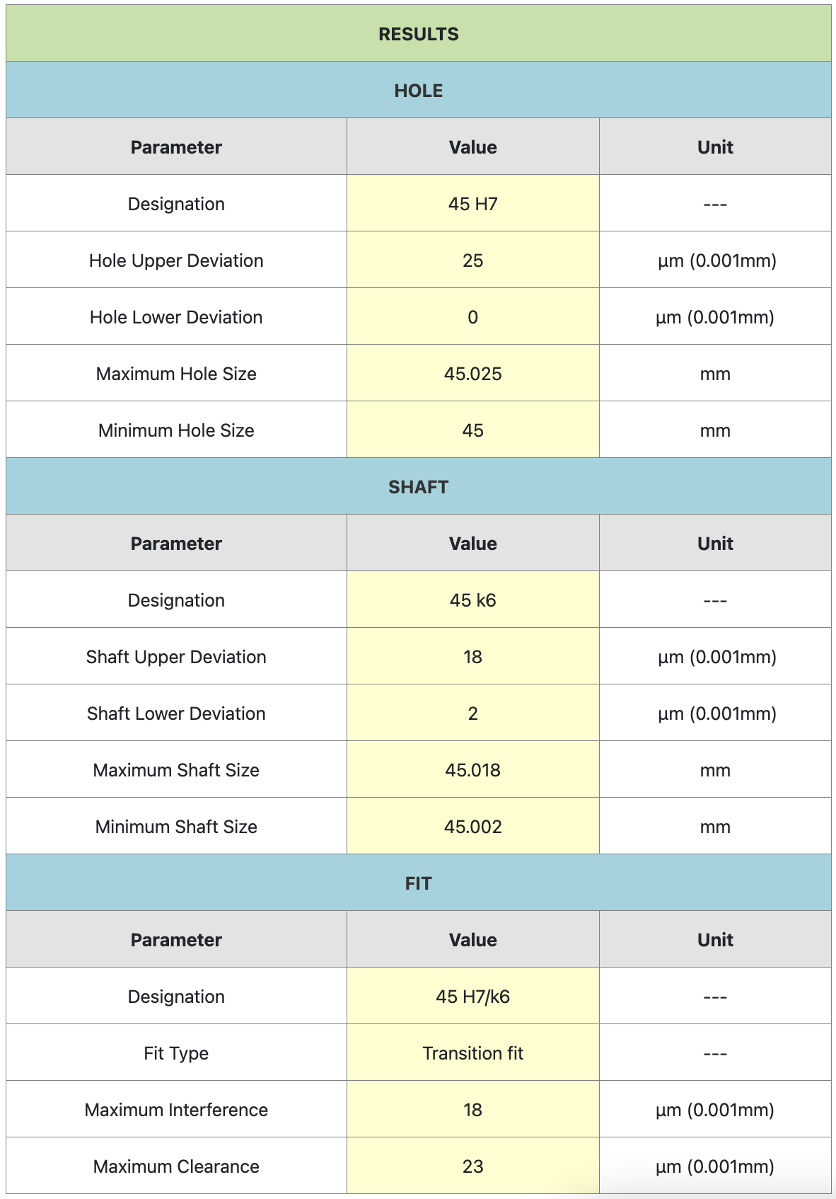

Source: <https://amesweb.info/fits-tolerances/tolerance-calculator.aspx>

# Shaft Two Analysis

## Gearing

Given: n1 = 2600 rpm, n3 = 400 rpm ideal, n1/n3 = 6.5 ideal

N1 = 19

N2 = 47

N3 = 27

N4 = 71

m = 0.005 m

Phi = 20 degree

Power H = 70000 W

n1/n3 = N4*N2/(N1*N3) = 6.5049

n3 = 2600/(n1/n3) = 399.7003 rpm

% error = (n3-400)/400 = -0.0749%

**Gear 2:**

Geometry

N2 = 47

Pitch Diameter: dp = N*m = 0.235 m

Pitch Radius: rp = dp/2 = 0.1175 m

Outer Diameter: do = dp + 2*m = 0.245 m

Root Diameter: dr = dp - 2*1.25*m = 0.223 m

Face Width: bw = 12*m = 0.06 m

Forces

Torque: T2 = 60*H/(2*pi*n2) = 635.975Nm

Wt23 = T2/rp = 5412.557 N

W23 = Wt23/cos(phi) = 1970.01 N

Wr23 = W23*sin(phi) = 5759.923 N

**Gear 3:**

Geometry

N3 = 27

Pitch Diameter: dp = N*m = 0.125 m

Pitch Radius: rp = dp/2 = 0.0675 m

Outer Diameter: do = dp + 2*m = 0.145 m

Root Diameter: dr = dp - 2*1.25*m = 0.123 m

Face Width: bw = 13*m = 0.065 m; Pinion has larger bw than gear

Forces

Torque: T3 = T2 = 60*H/(2*pi*n3) = 635.975 Nm

Wt34 = T3/rp = 9421.858 N

W34 = Wt34/cos(phi) = 10026.532 N

Wr34 = W34*sin(phi) = 3429.276 N

## 

## Free Body Diagram

Rotation Speed: n2 = n1*N1/N2 = 1051.0638

Set shaft diameter: d2 = 0.06 m

a = 0.0550 m [bw3/2 + bearing thickness/2 + spacing]

b = 0.0700 m [bw3/2 +bw2/2 + spacing]

c = 0.0500 m [bw2/2 + bearing thickness/2 + spacing]

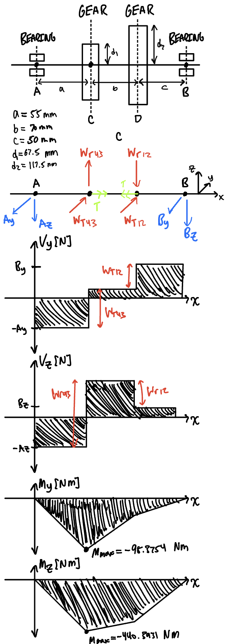

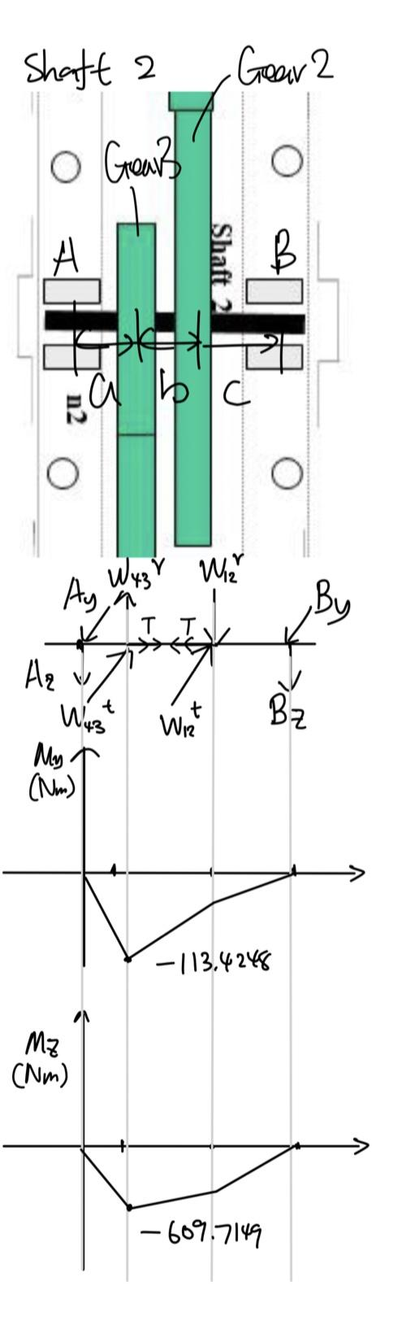

## Force Analysis

**Shaft 2 Reaction Forces**

## Shear and Bending

Maximum bending occurs at C:

Mz = Ay * a = 440.3931 Nm

My = Az * a = 98.3754 Nm

The shear at point C is:

Vy = Ay = 8007.1475 N

Vz = Az = 1788.6436 N

V = Sqrt(Vy^2 + Vz^2) = 6875.3362 N

### Shaft Fatigue Analysis

Solve for bending torsion, and shear stresses at Point 1 at cross-section C:

Given these stresses, calculate the mean and amplitude stresses for cyclic loading:

[ignore axial normal stress due to low magnitude]

[on/off]

Calculate Von-Mises given Kf = 3.000 and Kfs = 2.800.

Note: although max and max won’t coexist at the same point mechanically, we take both magnitudes into account for a conservative design on calculating the factor of safety for our shafts.

Calculate Infinite Criteria given chosen shaft material:

| **Material** | **E** | **UTS** | **Poisson Ratio** | **Ys** |
| --- | --- | --- | --- | --- |
| [AISI 1045 Steel](https://www.azom.com/article.aspx?ArticleID=6114) | 200000.0000 | 394.7200 | 0.2900 | 294.7400 |

[Grinding]

[Size Factor]

[99% Reliability]

[ignore temperature and miscellaneous factors]

Goodman

> 1.1 [The shaft design is safe]

Yield

## 

## Gear Stress Analysis

### Material

| **Gear Material** |  | **hardness** | **E (MPa)** | **Poisson Ratio** | **Type** |
| --- | --- | --- | --- | --- | --- |
| Gear 3 | AISI 1045 Carbon Steel | 500.0000 | 200000.0000 | 0.2850 | pinion |
| Gear 2 | AISI 1045 Carbon Steel | 400.0000 | 200000.0000 | 0.2850 | gear |

### Allowable Contact Stress

since

**Gear 2:**

MPa

**Gear 3:**

MPa

**Design Contact Stress**

**Gear 2:**

for no shock

Calculate Kv:

for commercial gears

m/s

Calculate Design Contact Stress

**Gear 3:**

for no shock

Calculate Kv:

for commercial gears

m/s

Calculate Design Contact Stress

### Allowable Bending Stress

Calculate number of shaft cycles:

**Gear 2:**

Calculate allowable bending stress

**Gear 3:**

Calculate allowable bending stress

### Design Bending Stress

**Gear 2:**

[module == 5mm]

[gear]

[not idler]

**Gear 3:**

[module == 5mm]

[pinion]

[not idler]

**Factors of Safety**

The design is good

## 

## Bearing Selection

[life hours]

n2 = n1*N1/N2 = 1051.0638 rpm [rotation speed]

[no shock]

[Deep Groove Ball Bearing]

[A and B calculated in Force Analysis section]

Initial Selection

[No Axial Force]

Choose SKF 6312 with ,

No reselection necessary since no thrust load

because

< e

Pick SKF 6312 for Final Bearing Selection with following specifications

| **Bearing Spec** | **C (N)** | **C0 (N)** | **d (m)** | **D (m)** | **W (m)** |
| --- | --- | --- | --- | --- | --- |
| SKF 6312 | 97500.0000 | 60000.0000 | 0.0650 | 0.1400 | 0.0330 |

Reference: <https://www.skf.com/group/products/rolling-bearings/ball-bearings/deep-groove-ball-bearings/productid-6312>

### Expected Lifetime of Bearing

[using C=97500 N from SKF]

Bearing does not require maintenance for intended operation of 5 years.

## 

## 

## Keyways and Tolerances

Gear Keyway (65 mm):



| Shaft diameter d (mm) | Key width W x height H |
| --- | --- |
| 58 < d <= 65 | 18 x 11 |

Fits:

Bearing inner ring and Shaft:

Interference fit (H7/p6) for hole basis. Interference needed for inner ring to rotate with shaft

Gear and Shaft:

Transition fit (H7/k6) for hole basis. Locational transition since shaft rotation will be transmitted from gear torque through interlocked key.

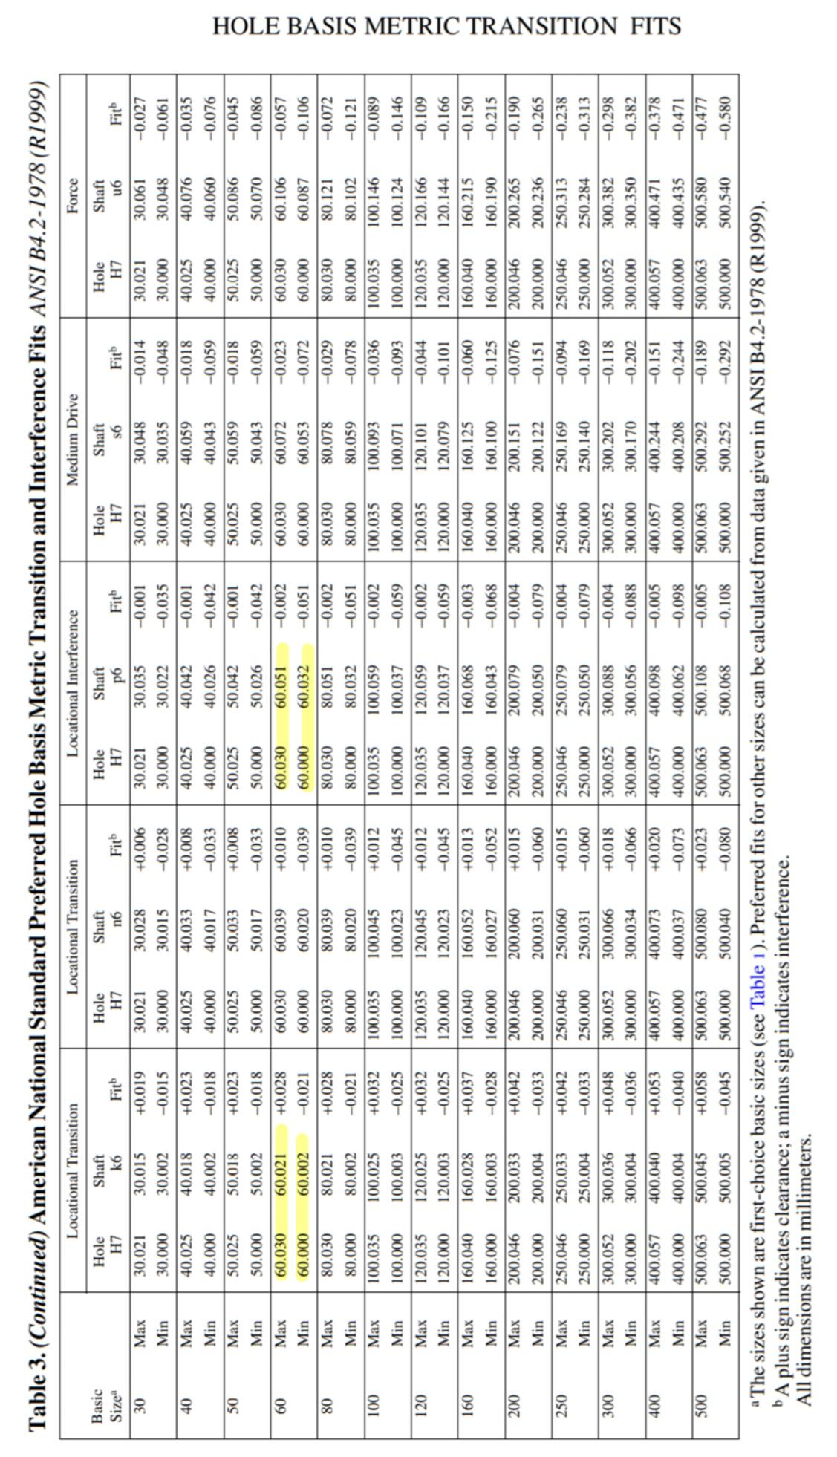

# 

# Shaft Three Analysis

## Gearing

Given: n1 = 2600 rpm, H = 70000 W

Choose gear teeth (odd number, indivisible):

N1 = 19

N2 = 47

N3 = 27

N4 = 71

Choose standard module m=5mm and pitch angle phi = 20 deg for off the shelf ordering:

m = a = 0.005 [m]

b = 1.25m = 0.00625 [m]

= 20 degree

Calculate transmission ratio:

n3 = 2600/(n1/n3) = 399.7003 rpm

% error = |(n3-400)/400| = 0.0749%

**Gear 4:**

Geometry

N4 = 71 [Teeth]

Pitch Diameter:

Pitch Radius:

Face Width:

Forces

Torque:

Gear Forces:

## Geometry

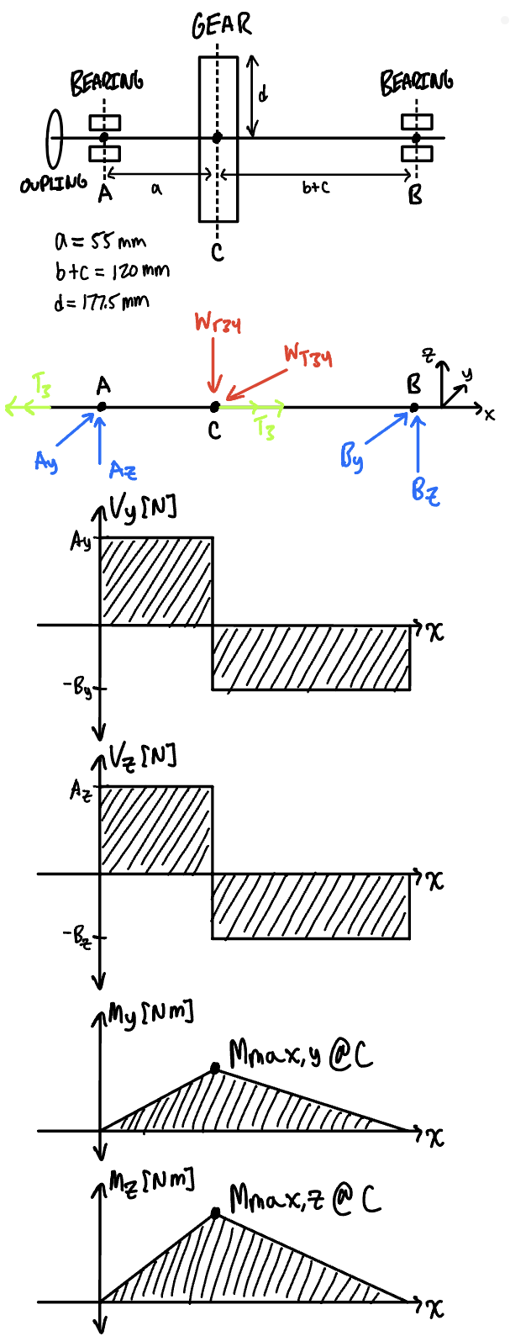



## Force Analysis

From the gearing section the following are solved:

From geometry we know the following:

Derived from static equilibrium, solve this system of equations:

System of equations yields the following reactions with force directions as drawn:

Ay = 6460.7027 N

Az = 2351.5035 N

By = 2961.1554 N

Bz = 1077.7724 N

## Maximum Shear, Bending

Maximum bending occurs at cross section C:

The shear magnitude at cross section C is:

Vy = Ay = 6460.7027 N

Vz = Az = 2351.5035 N

## 

## Shaft Stress Analysis

We first choose material:

| **Material** | **E [Pa]** | **UTS [MPa]** | **Poisson Ratio** | **Ys [MPa]** |
| --- | --- | --- | --- | --- |
| AISI 1045 Medium Carbon Steel | 200000.0000 | 565.0000 | 0.2850 | 310.0000 |

### Minimum Shaft Diameter

Our factor of safety is n=1.1

Calculate the torque magnitude at the coupling:

Calculate the minimum shaft diameter:

After unit conversion:

Consider keyway effect, round 5% increase [conservative]:

### Infinite Life at Critical Cross Section

Choose a shaft diameter of d = 55 mm at cross section C.

Solve for max bending torsion, and shear stresses at cross-section C experienced by point on the shaft surface:

Given these stresses, calculate the mean and amplitude stresses for cyclic loading:

[The shaft turns on and off]

This is a conservative estimate, since we use the shear and bending stress maximum amplitudes in calculating stress states, although these maximums are out of phase. Furthermore, we do not ignore shear (which is 30% of the mean shear).

Calculate Von-Mises given Kf = 3.000 and Kfs = 2.800 [conservative estimate]:

Calculate Infinite Criteria given chosen material:

[Grinding]

[Size Factor]

[99% Reliability]

[Chosen shaft diameter at C is safe]

### Yielding

[55mm shaft diameter does not pass yield line]

## 

## Gear Stress Analysis

Choose material for gear:

| **Gear Material** | **Hardness [HB]** | **E (MPa)** | **Poisson Ratio** | **Material Grade** |
| --- | --- | --- | --- | --- |
| AISI 1045 Carbon Steel | 400.0000 | 200000.0000 | 0.2850 | 1 |

### Bending

Calculate number of shaft cycles:

Rotation speed n3= 399.7003 RPM.

Calculate allowable bending stress:

[Stress cycle factor]

[Material strength for gear grade 1]

[Temperature not higher than 125 C, 99% reliability]

Calculate actual bending stress:

[Hamrock et al., 2005, N3=27, N4=71]

[No shock, Electric motor]

[Module = 5 mm]

[From Hamrock et al, 1999 table] []

[Non Idler]

[Rim thickness for solid disk]

Calculate Kv dynamic factor:

[Commercial gear]

Comparing the allowable to the actual bending stress:

The design is sufficient for bending stress since nb > n = 1.1

### Contact

Calculate allowable contact stress:

[Cycle factor]

[Hardness ratio]

[]

[Hardness Factor, for gear only]

[Temperature less than 125 C]

[99% reliability]

[Material strength for contact]

MPa

Calculate actual contact stress:

[No shock, electric motor]

[m = 5 mm]

[Same from bending]

[From bending calculation]

[Geometry factor]

### Factors of Safety for Bending and Contact

MPa

[Safe for contact stress]

[Safe for bending stress]

## 

## Bearing Selection

[lifetime hours]

n3 = 399.7003 RPM

[No Shock, electric motor]

[Ball Bearing]

[A and B calculated in Force Analysis section]

[No Axial Force]

Given the calculated C, I specify the following bearing from SKF:

| **Bearing Spec** | **C (N)** | **C0 (N)** | **d (m)** | **D (m)** | **W (m)** |
| --- | --- | --- | --- | --- | --- |
| 6311 | 74100.0000 | 45000.0000 | 0.0550 | 0.1200 | 0.0290 |

Reference: <https://www.skf.com/us/products/rolling-bearings/ball-bearings/deep-groove-ball-bearings/productid-6311>

This bearing is safe because the bearing specification C is less than our calculated C. Recalculation is not necessary since there is no thrust force and radial factor X is constant, not a function of e or C0.

### Expected Lifetime of Bearing

[using C=74100 N from SKF]

Bearing does not require maintenance for intended operation of 5 years.

## 

## Keyways and Tolerances

Coupling Keyway (50 mm) and Gear Keyway (55 mm):



| Shaft diameter d (mm) | Key width W x height H |
| --- | --- |
| 50 < d <= 58 | 16 x 10 |

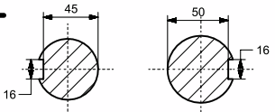

Fits:

**Bearing and Shaft: Interference fit (H7/p6), bearing should be tightly fit with shaft for fluid rotation.**

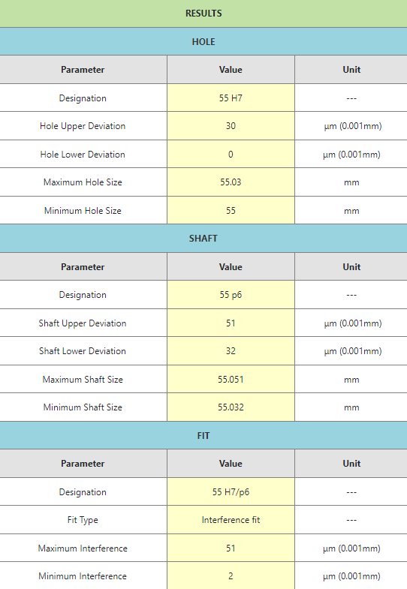

**Gear and Shaft: Transition fit (H7/k6), shaft rotation will be transmitted from gear torque through interlocked key.**

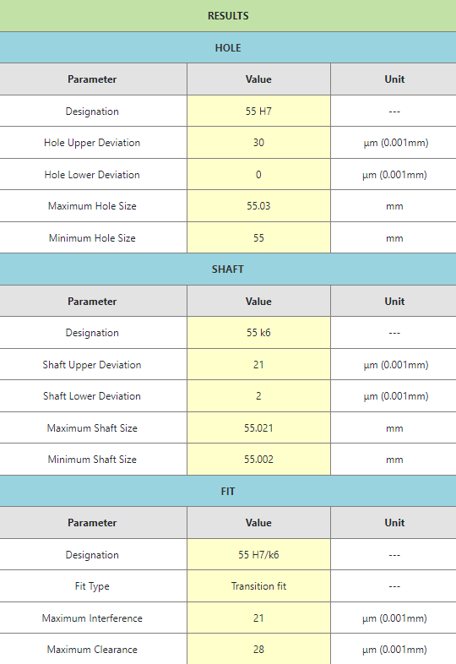

Source: <https://amesweb.info/fits-tolerances/tolerance-calculator.aspx>